Spark Training questions
Please answer the questions below

Exercise 1
Q1. Please put your code here:

import sys
from pyspark import SparkContext, SparkConf

if __name__ == "__main__":
if len(sys.argv) != 2:
print("Usage: wordcount <input_folder>", file=sys.stderr)
sys.exit(-1)

conf = SparkConf().setAppName("python-word-count")
sc = SparkContext(conf=conf)

text_file = sc.textFile("hdfs://" + sys.argv[1])
counts = text_file.flatMap(lambda line: line.split(" ")) \
.map(lambda word: (word, 1)) \
.reduceByKey(lambda a, b: a + b) \
.repartition(5) \
.filter(lambda x: len(x[0])>5)

# "takeOrdered" is an action.
list = counts.takeOrdered(40, key = lambda x: -x[1])
print("--------------------------------------------")
# print (repr(list)[1:-1])
print(*list, sep="\n")
print("--------------------------------------------")

Q2. Add print-screen of the stage proving you have 5 tasks

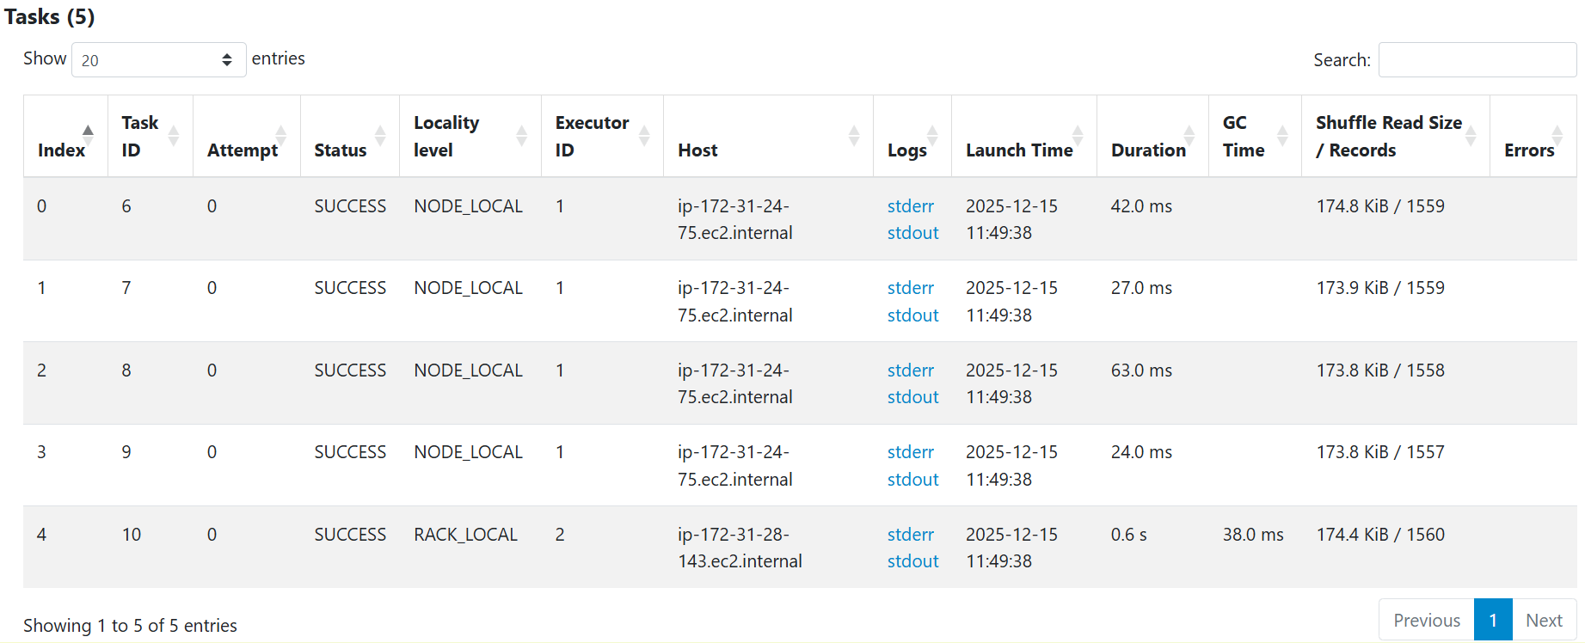

Exercise 2
Q1. Please put your code here:

import sys
from pyspark import SparkContext, SparkConf

if __name__ == "__main__":
if len(sys.argv) != 2:
print("Usage: wordcount <input_folder>", file=sys.stderr)
sys.exit(-1)

conf = SparkConf().setAppName("python-word-count")
sc = SparkContext(conf=conf)

text_file = sc.textFile("hdfs://" + sys.argv[1])
words = text_file.flatMap(lambda line: line.split(" ")).cache() # caching
distinct_words = words.distinct().count()

counts = words.map(lambda word: (word, 1)) \
.reduceByKey(lambda a, b: a + b) \
.repartition(5)\
.filter(lambda x: len(x[0])>5)

# "takeOrdered" is an action.
list = counts.takeOrdered(40, key = lambda x: -x[1])
print("--------------------------------------------")
# print (repr(list)[1:-1])
print(*list, sep="\n")
print("--------------------------------------------")

print("Total number of distinct words:", distinct_words)

Q2. Write the number of words found
77928

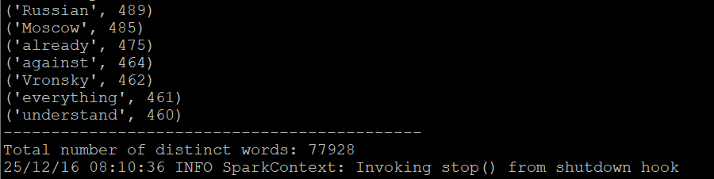

Exercise 3
Put a print-scrin with the DAG of the first stage, which shows it reads the files from s3a://<your_bucket_name>

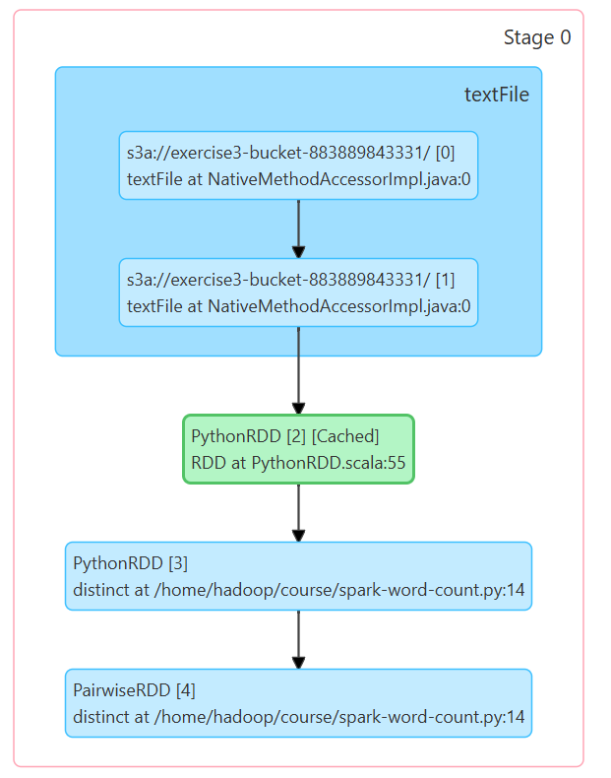

Exercise 4
Q1. Please put your code here:

import sys
from pyspark import SparkContext, SparkConf

if __name__ == "__main__":
if len(sys.argv) != 2:
print("Usage: wordcount <input_folder>", file=sys.stderr)
sys.exit(-1)

conf = SparkConf().setAppName("python-word-count")
sc = SparkContext(conf=conf)

text_file = sc.textFile("s3a://" + sys.argv[1])
words = text_file.flatMap(lambda line: line.split(" ")).cache() # caching
distinct_words = words.distinct().count()

counts = words.map(lambda word: (word, 1)) \
.reduceByKey(lambda a, b: a + b) \
.repartition(5)\
.filter(lambda x: len(x[0])>5)

# "takeOrdered" is an action.
list = counts.takeOrdered(40, key = lambda x: -x[1])
print("--------------------------------------------")
# print (repr(list)[1:-1])
print(*list, sep="\n")
print("--------------------------------------------")

print("Total number of distinct words:", distinct_words)

cleaned = words.map(lambda w: w.rstrip('.,')) # clean commas and dots
alpha_only = cleaned.filter(lambda w: w.isalpha() and len(w) > 0) # keep only alpahbetics words (no - : etc)

longest_word = alpha_only.reduce(
lambda a, b: a if len(a) >= len(b) else b
)

print("--------------------------------------------")
print("The longest word in the text is:")
print(longest_word)
print("Length:", len(longest_word))
print("--------------------------------------------")

Q2. Put here the printout of the longest word:

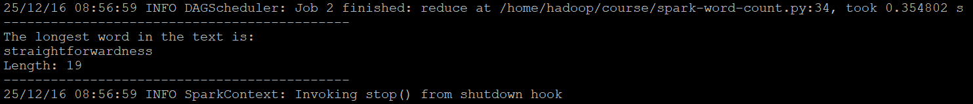

Exercise 5
Q1. Please put your code here:

import sys
from pyspark import SparkContext, SparkConf

if __name__ == "__main__":
if len(sys.argv) != 2:
print("Usage: count_words_in_line <input_path>", file=sys.stderr)
sys.exit(-1)

conf = SparkConf().setAppName("count-words-in-line")
sc = SparkContext(conf=conf)

text_file = sc.textFile("s3a://" + sys.argv[1])

# map each line to (line, number of words in the line)
line_word_counts = text_file.map(
lambda line: (line, len(line.split()))
)

# reduce to find the line with the most number of words
longest_line = line_word_counts.reduce(
lambda a, b: a if a[1] >= b[1] else b
)

print("--------------------------------------------")
print("Line with the most words:")
print(longest_line[0])
print("\nNumber of words:", longest_line[1])
print("--------------------------------------------")

Q2. Put here the printout of the line with the most words:

